Alex Arnold
Professor Torres
2-9-25
IT 0115-41197
Lab 02

Part A:
Research hardware requirements for Windows Server 2019
How much hard drive space is needed
Minimum drive space required is 32GB free space. (though this is an absolute minimum according to the Microsoft learn site)
How many processors/cores are needed
I did not see a core requirement for the processor. The only requirement I could find was a minimum of 1.4 GHz 64-bit (once again from the Microsoft learn site on the same page as before.)
How much hard drive space “should be allocated” per user
I could not find a definitive source that gave a recommendation other than virtual machine sizing guidelines that said 30 GB per user profile.
How do you update Windows drivers
Open Device Manager, navigate to the specific device you want to update, right-click on it, select "Update driver", and choose to either search automatically for updated drivers or browse your computer to install a downloaded driver from the manufacturer's website.
Alternatively, you may be able to update device drivers through windows update depending on driver availability.
Where do you find a hardware compatibility list for Windows servers
The Windows Server Catalog website tracks the hardware that meets the requirements set forth by Microsoft to be certified as compatible with different version of windows.

Part B:
Windows License requirements for Server 2019. Attempt to answer the below questions.:

How many licenses are needed for 100 users
There is no need for a separate license per user with the caveat that if the users are accessing the system remotely, they will need to have a Client Access License got each user / device that will access the server.
How many licenses are needed for 20 printers
There is no requirement for licenses per printer however there is once again a need for CAL licenses per each user / device that would like to print to the network printer connected to the server.
How much does Windows charge per core?
Windows charges on average $30 - $40 per core.
How much does Windows charge for 4 servers each with 2 -16 core processors?
$418.99 per license two would be needed per server so 8 in total making the total cost $3,351.92
How much does Windows charge to install in a virtual environment?
For the same 16 core license listed above in the standard version. The datacenter version (unlimited vms so long as the cores on the system are properly licensed) costs $2,699.99
What is the minimum memory requirement for Server 2019
512MB with core experience 2GB minimum with desktop interface but recommended 4GB
What is the maximum memory requirement for Server 2019
The maximum size is 24 TB for both standard and datacenter editions

Part C:
Use google to research on how to make the below changes (log onto Lab MCSA 70-740Links to an external site. for parts C and D)
On W2K16-DCA- Using GUI
change the hostname to Justice
To change the system name via the GUI
Start > Control Pannel > System and Security> System
Click change settings under computer name, domain, and work group settings
Click change under the Computer Name Tab
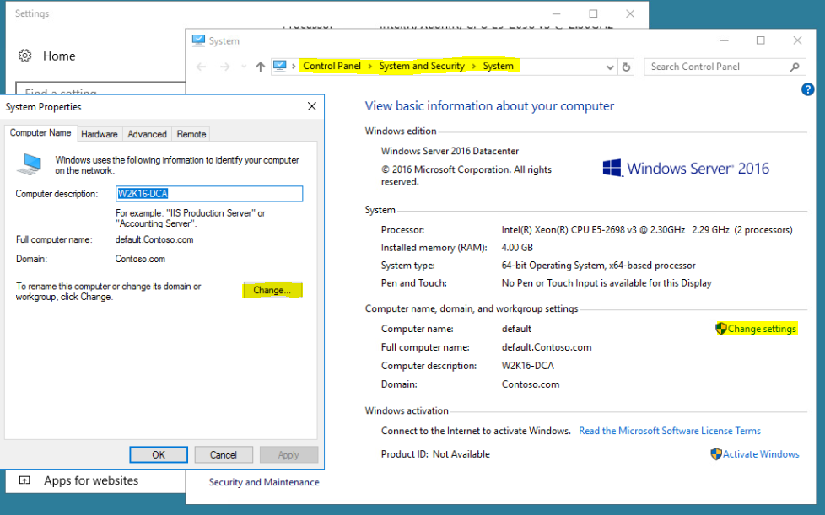
Then type in the new name into the Computer Name Field and click ok to save the change

Reboot the system
Start > power > restart
change the IP of Ethernet0 to 192.168.0.230/24, DNS=192.168.0.1, gateway=192.168.0.1 using the Server Manager
open the server manager > local server > Ethernet0
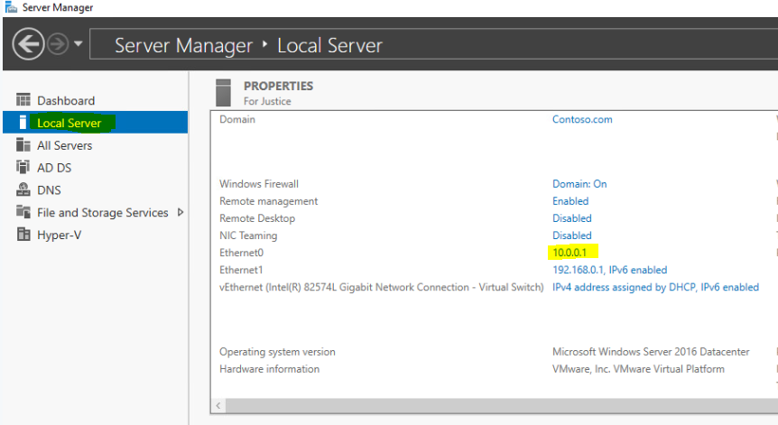
When you click the ip address on the page it will open the network and sharing center
Right click Ethernet0 > properties
Then select Internet Protocol Version 4 and click properties.
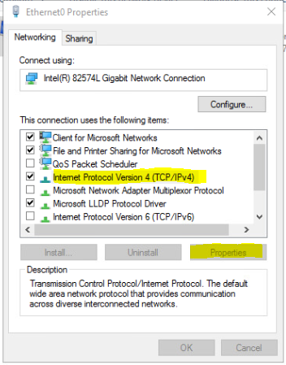
Then change the properties as needed
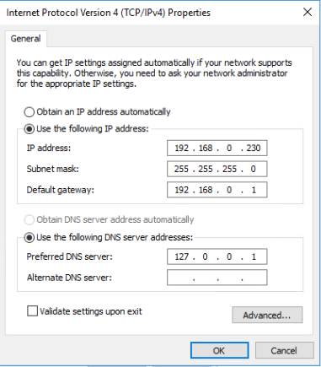

On W2K16-DCB- Using PowerShell
change the hostname to Avengers via PowerShell
Open powershell via the start menu and enter Rename-Computer -NewName Avengers -Force
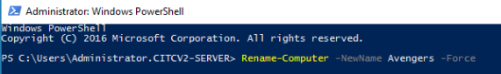
Reboot the system via PowerShell
The command Restart-Computer will reboot the server
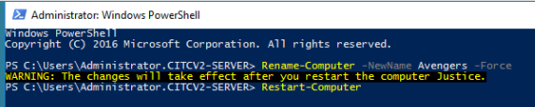
change the IP to 192.168.0.231/24 (add the default gateway and DNS of 192.168.0.1) via PowerShell
New-NetIPAddress -InterfaceAlias Ethernet0 -IPAddress 192.168.0.231 -PrefixLength 24 -DefaultGateway 192.168.0.1
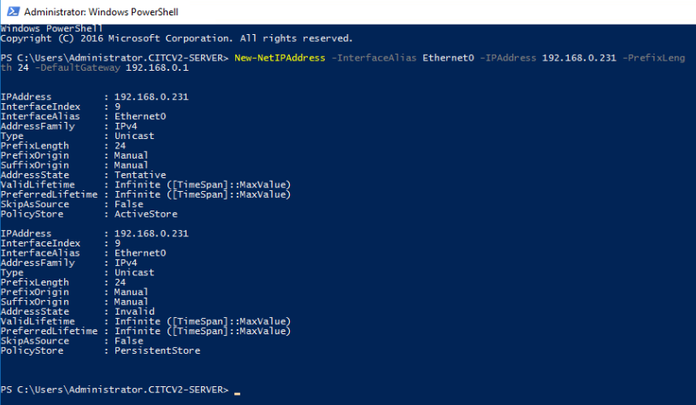

Part D:
Answer the below questions for DCA (GUI) and DCB (CLI). Provide screenshots:
How much hard drive space is on the server
DCA – 80GB total space on the system
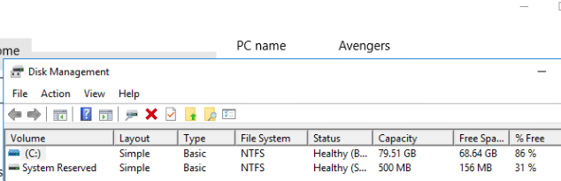
DCB 85 GB
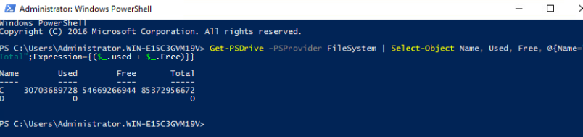
How much memory is on the server
DCA - 4 GB RAM
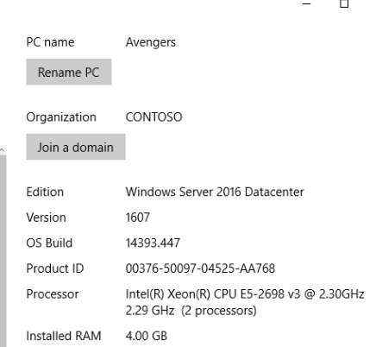
DCB 4GB
What processor is on the server
DCA – 2 Intel(R) CPU E5-2698 v3 @2.30GHz
DCB 2 Intel(R) Xeon(R) CPU E5 2698 V3 @2.30GHz
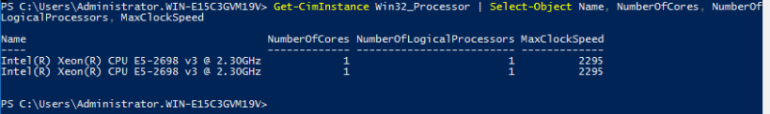
List the users on the system
DCA – just has the Administrator account
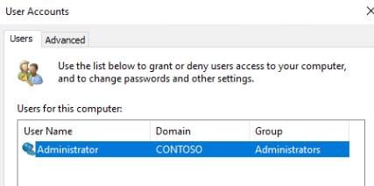
DCB – The only active user account on the system is the Administrator Account
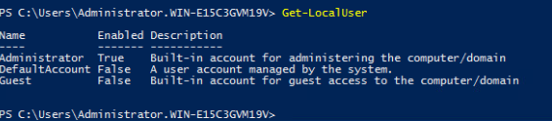
List the hostname for the server
DCA hostname – Avengers
DCB hostname – WIN-E15C3GVM19V
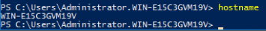
List the IP address on the server
DCA IP Address 192.168.0.1
DCB – Eth0 10.0.0.2
